**Deployment Guide Part II**

**You will need the following softwares in your computer:**

* [Visual Studio Community Edition 2013](http://www.visualstudio.com/en-us/products/visual-studio-community-vs.aspx)
* [PostgreSQL v9.4.0](http://www.postgresql.org/download/windows/)

**#Configuring IIS:**

**1# Enable the IIS within Windows features:**

**To turn Windows features on or off**

1. Swipe in from the right edge of the screen, and then tap **Search** or go direct to **Control Panel.**(If you're using a mouse, point to the lower-right corner of the screen, move the mouse pointer up, and then click **Search**.)
2. Enter **Turn Windows features on or off** in the search box, and then tap or click **Turn Windows features on or off,** or find “**Programs and Features”** in the Control Panel and Select “Turn Windows features on or off”.
3. To turn a Windows feature on, select the check box next to the feature. To turn a Windows feature off, clear the check box.
4. Check the Option Labeled “Internet Information Services”. Then, tap or click **OK**.

**2# Configuring Postgres file:**

1. Go to Program Files and open **POSTGRESQL.** Then open **“9.4”.**
2. Find the file **“pg_hba.conf”** and open.

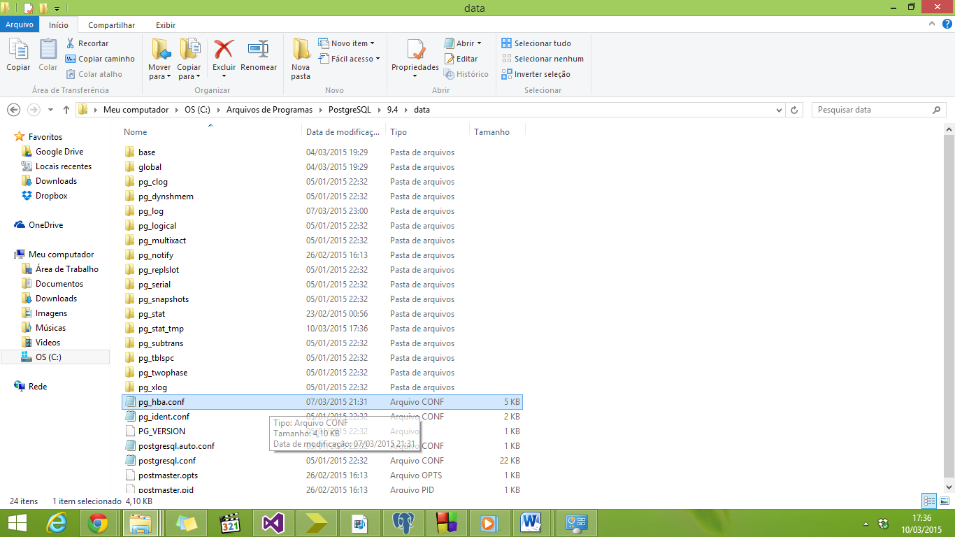

1. **Set the following configuration,vIn the last line copy and paste the code below:**

# TYPE   DATABASE       USER             ADDRESS                 METHOD

# IPv4 local connections:

host all all 127.0.0.1/32 md5

# IPv6 local connections:

host all all ::1/128 md5

# Allow replication connections from localhost, by a user with the

# replication privilege.

host all postgres samehost md5

host all postgres ::1/128 md5

host Assignment2.Proj2 "**George**" samehost sspi

host  Assignment2.Proj2 "**George**" ::1/128 sspi

**Where you see George replace by the name of the user in your Database.**

**3# Well Done!** Now you can use Npgsql connection with Integrated Security instead of your password. Your connection string should look like the string below:

NpgsqlConnection conn = new NpgsqlConnection("Server=127.0.0.1; Port=5432; Database=Assignment2.Proj2; Integrated Security=true;");

**#Enabling Nuget Package:**

.NET libraries for linking our code with PostgreSQL will be done using Npgsql: [Npgsql for PostgreSQL](http://npgsql.projects.pgfoundry.org/)

Once you have the project open:

1. **In the solution explorer**, right click the top level solution and select **‘Enable NuGet Package Restore**’

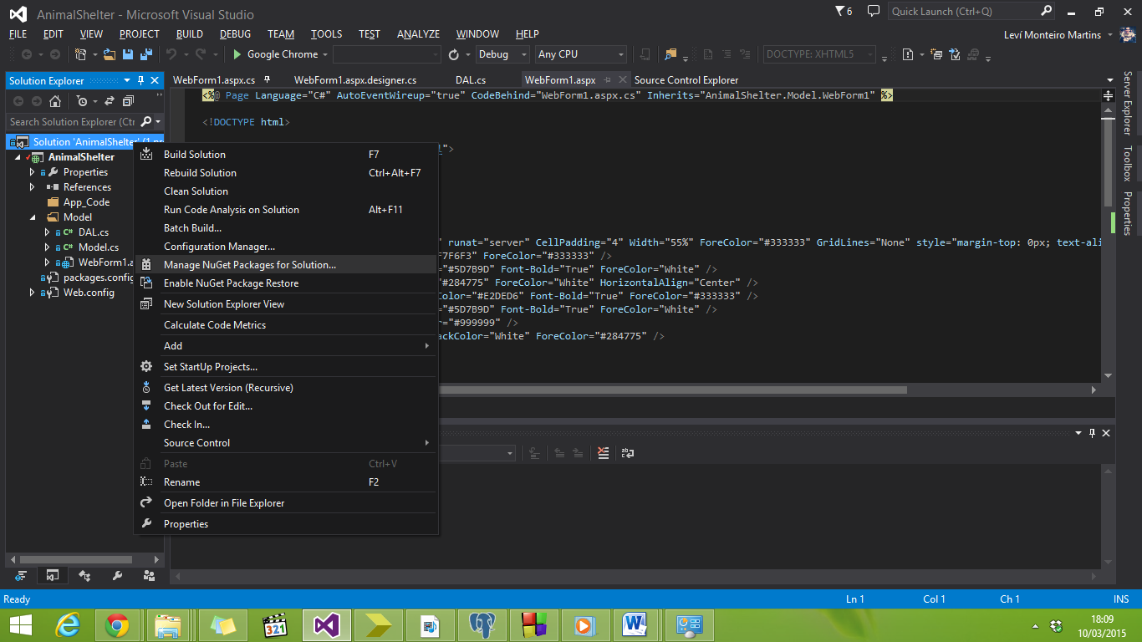

Once enabled, right click the solution and select ‘**Manage NuGet Packages for Solution’**

* 1. Under ‘Online’, select ‘All’
  2. 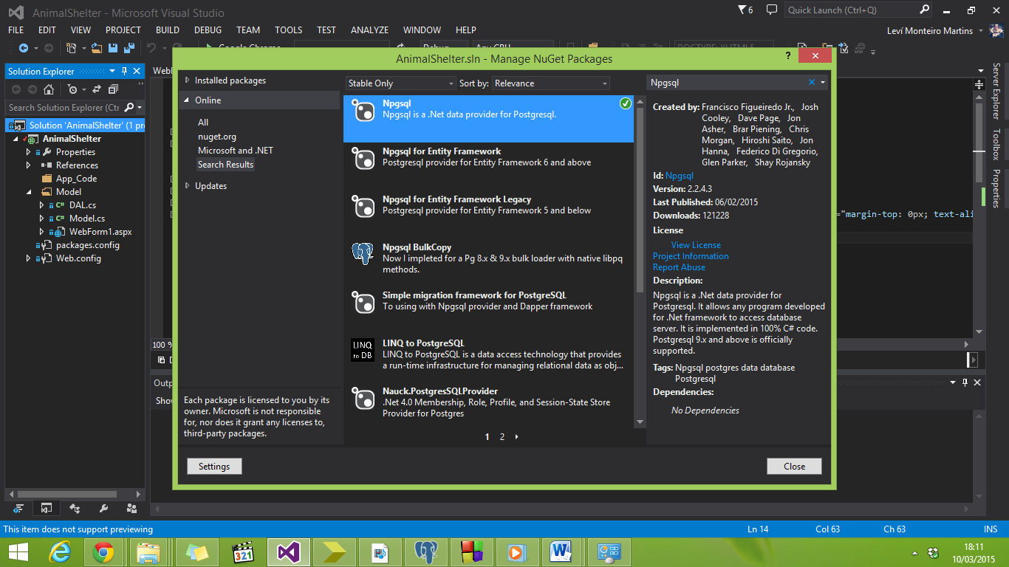Search for and install **‘Npgsql’**